**SQL Practice Questions for Superstore Dataset (MySQL Workbench)**

**Step 1: Loading the Data**

1. **Create a table to store the Superstore dataset.**
   * **Ensure the correct data types for each column.**
2. **Load the data into the table.**
   * **Use LOAD DATA INFILE or import via MySQL Workbench.**
3. **Check if all rows are loaded properly.**
   * **Example: If the dataset has 48620 data rows, COUNT(*) should return 48620.**

select

count(pizza_id)

From pizza_sales ;

1. **Verify the column names and data types.**

Use DESCRIBE pizza_sales data; to confirm the structure.

**DESC pizza_sales;**

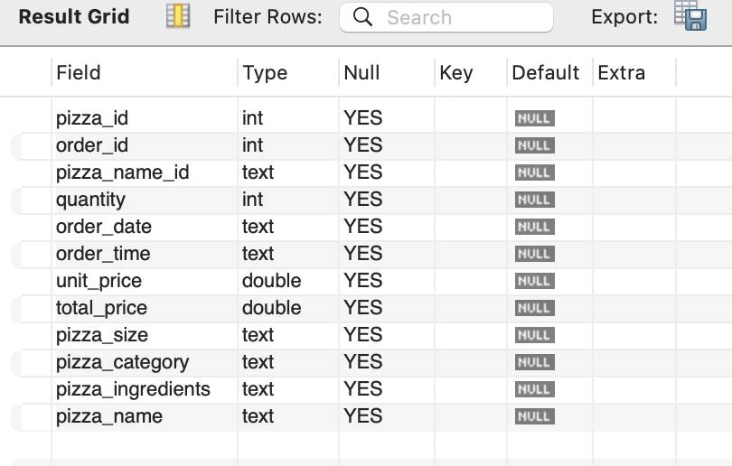

**Step 2: Basic Data Exploration**

1. **Preview the first 10 rows.**

select *

FROM pizza_sales

limit 10;

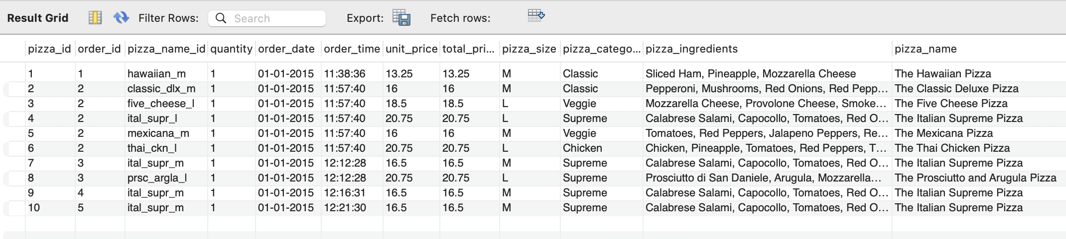

1. **Count the total number of unique customers.**

SELECT COUNT(DISTINCT order_id) FROM pizza_sales;

Return 21350

1. **List all unique sales by size.**

SELECT COUNT(DISTINCT order_id) as Pizza_Order, pizza_size

FROM pizza_sales

group by pizza_size;

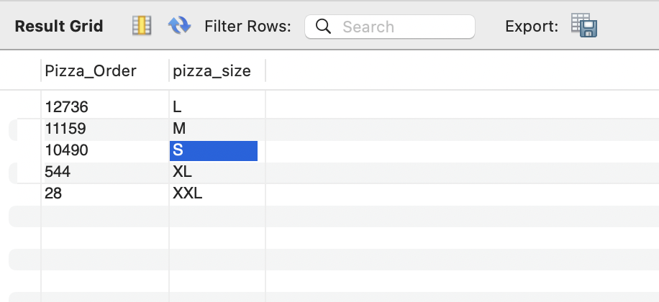

1. **Find the number of unique catagories in the dataset.**

**select distinct pizza_category**

**From pizza_sales;**

1. **Find the total number of orders per year.**

SELECT DISTINCT substring(order_date, 7,4)AS YEAR, sum(distinct order_id) FROM pizza_sales

group by order_date;

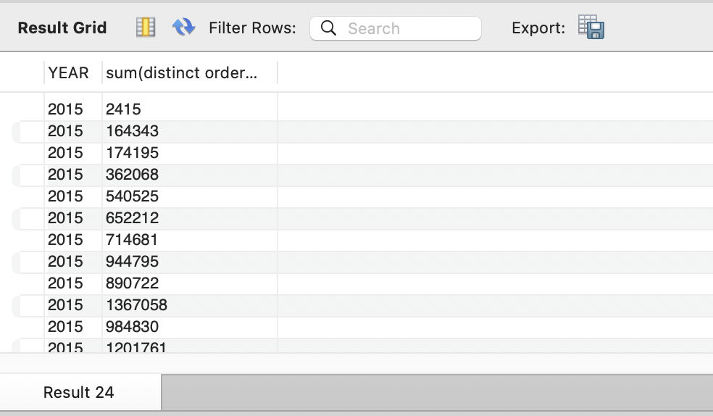

**Step 3: Filtering & Sorting Data**

1. **Find all orders placed in December 2015.**

SELECT COUNT(order_id) AS unique_orders_dec

FROM pizza_sales

WHERE MONTH(STR_TO_DATE(order_date, '%d-%m-%Y')) = 12;

1. **Find the top 5 Months with the highest total sales.**

**First find all total sales of each month**

SELECT

MONTH(STR_TO_DATE(order_date, '%d-%m-%Y')) AS month,

YEAR(STR_TO_DATE(order_date, '%d-%m-%Y')) AS year,

SUM(total_price) AS total_sales

FROM pizza_sales

GROUP BY year, month

ORDER BY year, month;

**Then top five**

SELECT

MONTH(STR_TO_DATE(order_date, '%d-%m-%Y')) AS month,

YEAR(STR_TO_DATE(order_date, '%d-%m-%Y')) AS year,

SUM(total_price) AS total_sales

FROM pizza_sales

GROUP BY year, month

ORDER BY total_sales DESC

limit 5;

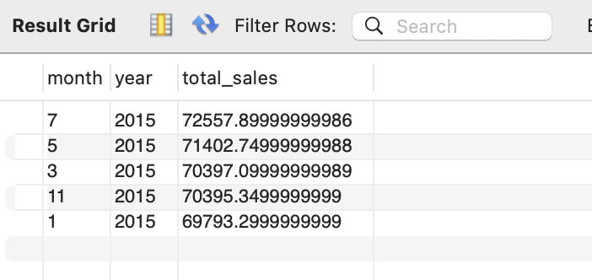

1. **Find the top 3 most profitable product categories.**

select distinct pizza_category, sum(total_price) As Pizza_Sale_per_catagory

From pizza_sales

group by pizza_category

order by Pizza_Sale_per_catagory Desc;

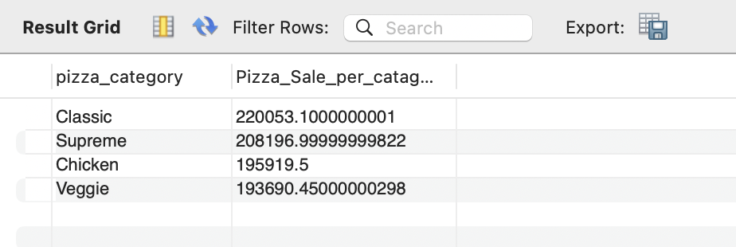

select distinct pizza_category, sum(total_price) As Pizza_Sale_per_catagory

From pizza_sales

group by pizza_category

order by Pizza_Sale_per_catagory Desc

limit 3;

1. **Retrieve all orders where the discount given is more than 50%.**

**Step 4: Data Cleaning**

1. **Identify duplicate records.**

select pizza_id, count(*) As Check_duplication

from pizza_sales

group by pizza_id

Having count(*)>1 ;

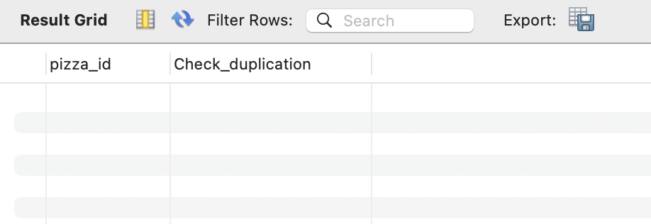

1. **Check for missing values in important columns (order_id and pizza_id).**

select pizza_id,order_id

from pizza_sales

where pizza_id= null & order_id=null ;

1. **Standardize the State column to remove extra spaces.**

select trim(pizza_id), trim(pizza_name ),trim(pizza_category)

From pizza_sales

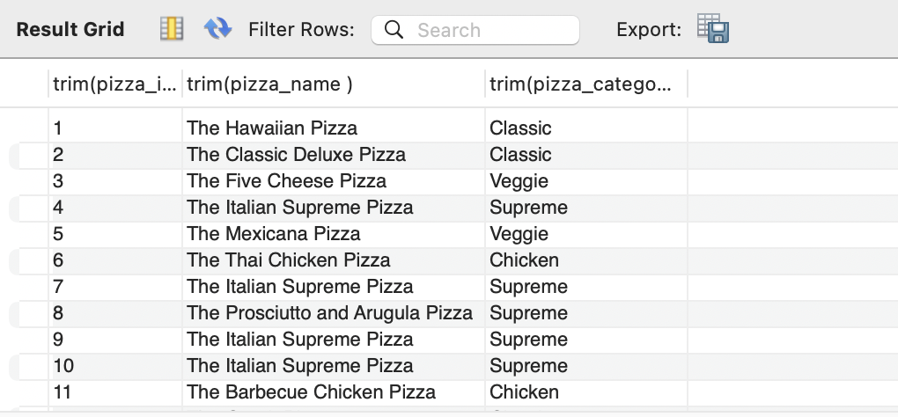

1. **Convert Order Date to the correct date format (if needed).**

select order_date, STR_TO_DATE(order_date, '%d/%m/%Y')

from pizza_sales;

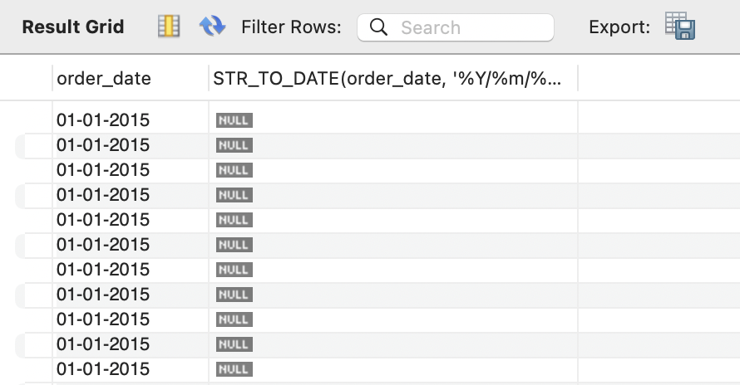

1. **Ensure Profit column contains only numerical values.**

**Step 5: Aggregation & Grouping**

1. **Find total sales, total quantity, and total profit per year.**

SELECT

YEAR(STR_TO_DATE(order_date, '%d-%m-%Y')) AS year,

SUM(total_price) AS total_sales,

Sum(quantity) As Total_Quantity

FROM pizza_sales

GROUP BY year;

1. **Calculate the average discount per product category.**
2. **Find the pizza_size who placed the highest number of orders.**

select pizza_size, sum(total_price) as Highest_Sale

From pizza_sales

group by pizza_size

order by Highest_Sale DESC;

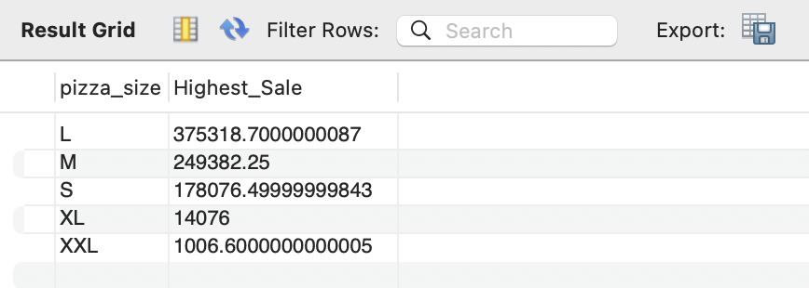

1. **Determine the month with the highest total sales.**

SELECT

MONTH(STR_TO_DATE(order_date, '%d-%m-%Y')) AS month,

SUM(total_price) AS total_sales

FROM pizza_sales

GROUP BY month

ORDER BY total_sales DESC;

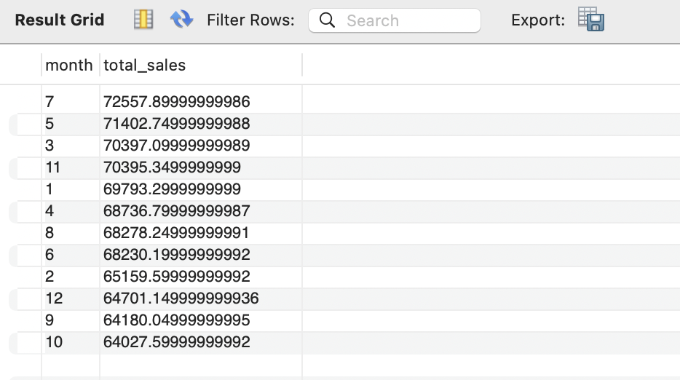

**Step 6: Joins & Relationships**

1. **Create a customers table and link it to superstore_data using Customer_ID.**
2. **Join customers with Pizza_sales to get total sales per customer.**

select pizza_name_id, count(*) As Customers

from pizza_sales

group by pizza_name_id

Having count(*)>1 ;

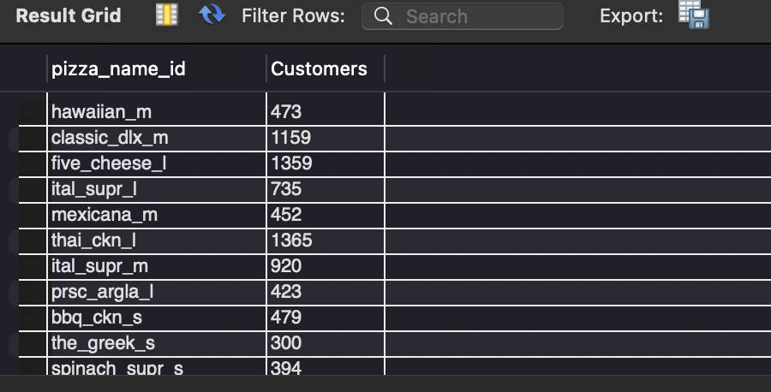

**Step 7: Advanced SQL**

1. **Create a new column Profit Margin (%) and fill it up by the following formula:.**
   1. **(Profit/sales) * 100**

alter Table pizza_sales

add column Profit_10_percent varchar(100);

UPDATE pizza_sales

SET profit_10_percent = total_price * 0.10;

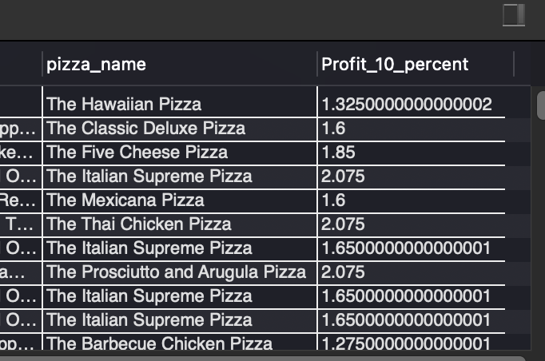

1. **Identify the three least profitable products.**

select pizza_name_id, total_price,profit_10_percent

from pizza_sales

order by profit_10_percent DESC

limit 3;

1. **Rank customers by total sales.**
2. **Find the most frequently ordered product.**

select pizza_name_id, order_id,pizza_size

from pizza_sales

order by pizza_name_id DESC

limit 10;

